TECHNICAL REQUIREMENTS
for the purchase of bucket trucks with a telescopic lift arm 18 m. + on the car chassis

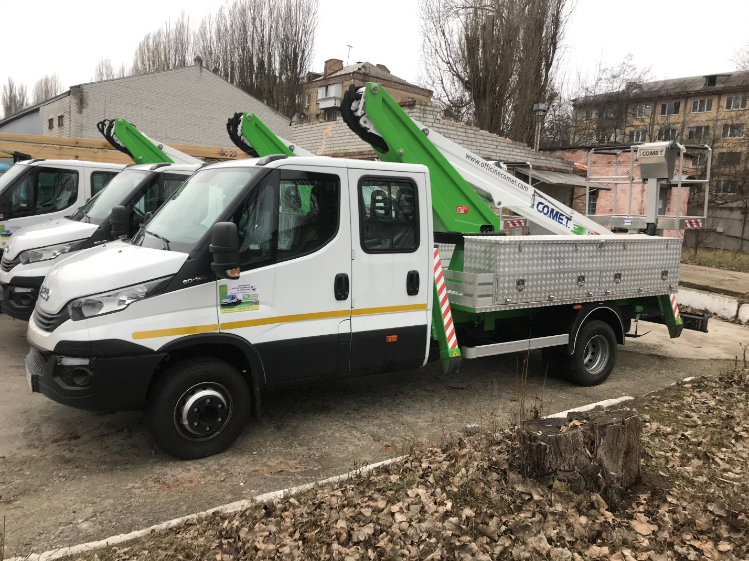

Name of the parameter | Required by the Customer | Proposed by the Participant
The technical parameters of the bucket truck with a lifting height of 18 meters with a telescopic lift arm made in the form of box sections with extension using the hydraulic cylinder
Maximum chair lifting height, not less than, m; | Not less than 18 m
Maximum chair spread, no less than, m; | Not less than 10.7 m
Chair carrying capacity with up to 7 m spread and more than 7 m spread, respectively, not less than, kg | 250/80
Arm rotation angle, degrees, not less than, degrees. | Not less than 360
Arm control system | Hydraulic distributor
Support control system | Hydraulic distributor
Overall dimensions of the bucket truck (length/width/height) in the transport position, not more than, m: | <= 9.0/2.56/3.8
Turning radius (according to the size of the main arm), m | 12
Operating temperature, degrees C | +/- 40
Chair electrical insulation, V
The installation of lighting for the fitter's workplace on the chair working surface | Available
Year of manufacture | No earlier than 2022
The warranty period for the equipment (installation) is at least, months/hours (whichever takes places first) | =>18 months or  400 motor/hours
The warranty period for the chassis is at least | =>24 months or 100,000 km
Ecology standard (norm of toxicity), not worse than | Not worse than EURO-5
- General technical requirements for the basic chassis
Wheel formula | 4x4
Fuel type | Diesel
Engine volume, not more than, cm3 | 5200
Engine type | In-line, 4-cylinder, 4-stroke engine, with turbocharging and cooler, with direct fuel injection
Engine power, no less than,  hp/ rpm | => 145/2800-3500
Chassis total weight, no less than, kg | => 6,000
Antifreeze coolant | Available
The base chassis frame | Reinforced, taking into account the load capacity of the lift equipment
Front suspension | Independent, torsion bar, reinforced, with a double-acting telescopic shock absorber, or dependent, equipped with two double-lug springs, double hydraulic telescopic shock absorbers, rubber travel limiting buffers, anti-roll bar
Rear suspension | Parabolic, multi-leaf with a double-acting telescopic shock absorber or dependent, spring, with double-acting hydraulic telescopic shock absorbers, rubber travel limiting buffers, anti-roll bar
SPA (spare parts and accessories) | Available
Gearbox | Mechanical, 5-6-speed transmission
Quantity of seats in the cabin | 7 seats – two seats for passengers in the first row, four seats for passengers in the second row
A storage compartment under the passenger seats of the second row of the cabin | Available
Air conditioner | Available
Wheel steering | With hydraulic booster and height adjustment
Horn about the reverse movement | Available
Auxiliary brake systems availability | - ABS – antilock braking system or equivalent;  - ASR – traction control system or equivalent;  - EBD – brake force distribution system or equivalent.
Full size spare wheel | Available
Power transmission to the power take-off box | Shaft drive or directly to the gearbox
Safety seat belts for driver and passengers | Available
Requirements for cabinet material
Corrugated sheet aluminum not less than, mm | =>3
All sharp edges shall be covered with protective coating | Yes
Each box shall be equipped with hinges for locking | Yes
Service interval – | 20,000 km or 400 hours or once a year, whichever comes first
Year of manufacture | No earlier than 2022
Additional equipment
Heated rearview mirrors | Available
Audible alarm about the reverse moving | Available
Rearview camera or parking sensors on the back of the car | Available
Levelling jack, psc | Available, 1
Wheel wrench, pcs | Available, 1
Thrust shoes, psc | Available, 2
Triangular safety reflector, psc | Available, 1
Reflective jacket, psc | Available, 1
Fire extinguisher, psc | Available, 1 pcs
Road sign “3.29 Maximum speed limit 40 km", pcs | Available, 1 pcs
Road sign“3.29 Maximum speed limit 20 km", psc | Available, 1 pcs
Road sign “1.37 Road works", psc | Available, 1 pcs
Road sign “4.8 detour of an obstacle on the left side", psc | Available, 1 pcs
Traffic cone  450–520 mm high, psc | Available, 8 pcs
Outrigger pads for outriggers, 300x300x50 mm in size, made of polymeric materials designed for loading the lift | Available, 4 pcs
The auto-hydro lift is equipped with a place for reliable storage and transportation of outrigger pads. | Available
A truck side of not less than 350 mm height around the entire perimeter | Available
Manufactured and installed on the vehicle platform (on the left side along the way) a cabinet for materials | Yes

- General requirements for manufacturers and suppliers of lifts and basic chassis
  - Production plants shall produce new bucket trucks according to the specifications developed and agreed with the State Labor Service of Ukraine in accordance with the requirements of the Rules for Construction and Safe Operation of Lifts RAOHS 0.00-1.36-0318 and the requirements of the Technical Regulations for Machinery Safety.
  - The availability of service centers of the production plant or other organizations that have an official license from the production plant to perform warranty and restoration repairs of bucket trucks and the base chassis in Ukraine.
  - Experience in the production and supply of the proposed special equipment - at least 2 years. Participants shall submit the manufacturer's reference list indicating the types, quantity of delivered vehicles, delivery time (the minimum allowable period for displaying in the reference list – 2 years before the date of the auction), the name and contacts of the company (address, telephone number, contact person) that carried out the special equipment supply.
  - The production plant or trade organization shall carry out pre-sale preparation of the bucket truck, TS-1 on the automobile chassis, delivery of the bucket truck to the buyer's warehouse with the issuance of all necessary documents for registering the bucket truck at the Regional Service Center of the Ministry of Internal Affairs of Ukraine and subdivisions of the State Labor Service of Ukraine.
  - The bucket truck, in accordance with the RD or the program and methodology for validation tests, shall pass the manufacturing quality check, with a mandatory mark in the proof of acceptance in the bucket truck passport.
  - For bucket trucks manufactured abroad, it is mandatory to have a design certificate of conformity with traffic safety requirements for registration at the Regional Service Center of the Ministry of Internal Affairs and the document on compliance with labor protection regulations in Ukraine for imported equipment issued by the Kyiv or territorial expert and technical center.
- General technical requirements for a bucket truck
  - Bucket trucks, both domestic and made abroad, shall have certificates of conformity confirming their compliance with the requirements of the Technical Regulations for Machinery Safety, approved by the Resolution of the Cabinet of Ministers of Ukraine of January 30, 2013, No. 62.
  - The bucket truck, in accordance with the RD or the program and methodology for validation tests, shall pass the manufacturing quality check, with a mandatory mark in the proof of acceptance in the bucket truck passport at the production plant.
  - The bucket truck must be new, in the factory version.
  - The bucket truck chassis should minimum comply with Euro-5 environmental standards for pollutant emissions, regulatory requirements for greenhouse gases, electromagnetic radiation, noise levels, spillage of oils, lubricants, technical fluids and other factors of negative impact on human beings and the environment.
  - Materials for the manufacture of critical metal structures shall fully comply with the requirements of regulatory documents (RD 22-16-2005, etc.) and have quality certificates.
  - The stability of bucket trucks shall be ensured in any position of the lift arm.
  - The body and working units shall have reliable protection against metal corrosion. Units and mechanisms should not have mechanical damage, deformation, loosening in places of their fastening. Welding seams should not have cracks, overlaps, slag inclusions and metal undercuts. The hydraulic system shall ensure smooth operation of all units without jerks and shocks. The hydraulic system shall not have leaks, metal pipelines should be galvanized. Bolted connections shall be securely tightened. Arbitrary loosening of bolts and nuts shall be prevented by installing lock plates, spring washers, safety nuts and studs.
The operating fluid used in the hydraulic system shall meet the current requirements of the standards for hydraulic oils, the actual operating conditions of the vehicle, loads, seasonality, etc.
Safety and alarm devices (sound and light), switches (terminals), limiters, locks, incl. hydraulic ones, grounding system and elements, insulators, visualization elements shall comply with current standards and requirements for safety, placement and application, which are provided for lifting equipment.
Manufacturer's identification plates shall be securely fastened, accessible for visualization and provide the necessary information in part, at least: the name (names) of the lifting equipment, the name of the manufacturer, serial (factory) number, production date, load capacity, compliance with the standard, maximum lifting height.
  - The supplier shall provide the bucket truck on the vehicle with a complete, usual set of tools, and service spare parts and accessories kit.
  - The supplier shall run all necessary customs procedures for registering the import of the bucket truck in the territory of Ukraine (if necessary).
  - The supplier shall provide warranty service during the warranty period, as well as provide a certificate of availability of vehicle service stations. The certificate should contain the name of the service center, location, and telephone/fax numbers.
  - List of documents to be provided by the Supplier as part of the offer:
- operating and maintenance instructions,
- certificate of compliance with the requirements of the Technical Regulations for Machinery Safety, approved by the Resolution of the Cabinet of Ministers of Ukraine of January 30, 2013, No. 62;
- copies of certificates for the equipment of the production plant or certificates of conformity, in case of their absence, a letter of guarantee on the provision of documents upon delivery of the goods;
- the copy of the permit for the use of bucket trucks issued by the State Labor Service of Ukraine. For foreign made bucket trucks – the conclusion of the examination of compliance of machines, mechanisms, equipment of heightened danger with the requirements of legislation on labor protection and industrial safety issued by the authorized organization in Ukraine.
- Certificate of conformity in terms of the requirements for the vehicle (clause 8 of the Rules for State Registration of Vehicles approved by the Resolution of the Cabinet of Ministers of Ukraine of September 7, 1998, No. 1388).
- List of documents for registration at the Regional Service Center of the Ministry of Internal Affairs of Ukraine.
– The TU copy with a mark of approval with the Central state authority in the field of safety and labor protection of Ukraine.
- The copy of the installation permit, dismantling, adjusting, maintenance of machines, mechanisms, equipment of increased danger issued by the State Service for Mining Supervision and Industrial Safety of Ukraine.
- The letter from the manufacturer confirming the fuel consumption of the vehicle per 100 km in the combined cycle and per 1 motor/hour of equipment operation.
  - List of documents to be provided by the Supplier upon delivery of the bucket truck:
– all necessary documents for registration at the Regional Service Center of the Ministry of Internal Affairs of Ukraine;
- operating and maintenance instructions;
- Bucket truck Passport issued by the manufacturer with filled in accounting information, detailed information about systems, equipment, safety devices, assemblies, materials, kinematic and schematic diagrams used in the manufacturing of the bucket truck, signatures and seals, as well as filled in data in the certificate of acceptance in the Bucket truck Passport.
  - The bucket truck shall be equipped with a motor/hour meter.
  - Safety devices shall meet the requirements of the rules for the design and safe operation of bucket trucks RAOHS 0.00-1.36-03.
  - The bucket truck hydraulic equipment shall meet the requirements of GOST 17411.
  - Brands of the working fluid shall comply with the requirements of VMGZ – TU 38.101479, MGE-46V – TU 38.001347, I-30A – GOST 20799 or similar, which, in terms of technical characteristics, are not worse than the specified qualities and standards (GOST, TU, API, ISO).

ADDITIONAL REQUIREMENTS
FOR THE PURCHASE OF BUCKET TRUCKS ON CAR CHASSIS
- To provide participants with advertising products in the form of advertising booklets, brochures or prospectuses with the offer.

- The procedure for checking and accepting a bucket truck on a car chassis:
The bucket truck on the car chassis is handed over to the customer only after carrying out a complex of works related to pre-sale service and its acceptance by the manufacturer's department of technical control (DTC), tests at the manufacturer according to the developed methodology and with a mandatory note in the passport on passing the test and conducting tests jointly by the Supplier and the Buyer in the Buyer's warehouse.
Ownership of the Goods, the risk of destruction or damage to the Goods shall pass from the Supplier to the Buyer from the date of delivery of the Goods and signing of the invoice.
Mandatory submission of documents required for registration at the Regional Service Center of the Ministry of Internal Affairs of Ukraine, a sales contract, an act of inspection of the sold vehicle have been entered in the electronic register and in the NAIS automated database, transit license plates, a copy of the dealer agreement and the Certificate of acceptance and transfer between distributor and dealer (for an official sales representative – certificate), delivery and acceptance certificate between the Supplier and the Buyer, a certificate of design approval to ensure road safety, certificates of conformity with annexes or a document confirming that the Goods are not subject to certification in Ukraine, copies of the customs declaration (for foreign production) hereinafter referred to – Registration Documents provided simultaneously with the delivery of the Goods to the Buyer's warehouse. In the case of failure to provide a complete package of Registration Documents at the "Regional Service Center of the Ministry of Internal Affairs" within 5 calendar days as of the date of delivery, the registration and costs of registration of a vehicle are the responsibility of the Supplier, in this case the Supplier must register the vehicle within 10 calendar days as of the date of Goods delivery under the terms of this Agreement.
Documents for registration at the "Regional Service Center of the Ministry of Internal Affairs" are provided once upon delivery of the Goods to the Buyer's warehouse.

- Bidders must have copies of documents that confirm the manufacturer of the products, namely:
- copies of valid Certificates of Conformity for the Product, according to the current legislation of Ukraine, a certificate of design approval to ensure the road traffic safety, a certificate of assignment of the International Identification Code of the manufacturer of road vehicles (WMI) and the symbols of the vehicle identification number (VIN), technical conditions.

